N5
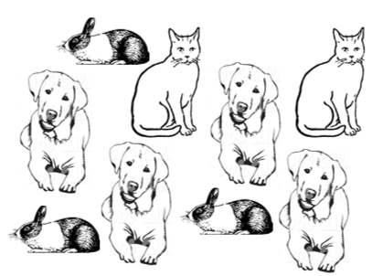
What is the ratio of dogs to all pets?

A) 4 : 5
B) 4 : 9
C) 5 : 4
D) 5 : 9

N5
Which of the following is NOT a correct way to describe the ratio of cats to dogs?
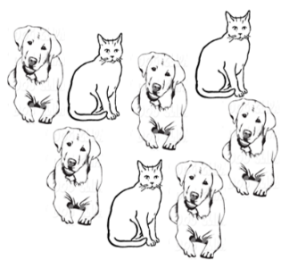
A) three to five
- 3 to 5
- 3 : 5
- $\frac{3}{5}$

N5
What is the ratio of butterflies to ladybugs?
A) 11 : 4
B) 4 : 11
C) 4 : 3
D) 3 : 4

N5
Which of the following lists represents the correct ratio of ladybugs to dragonflies?
- 3:4, $\frac{3}{4}$ , 3 to 4
- 7:11 $\frac{7}{11}$ , 7 to 11
- Four to three, 4:3, 4 to 3
- Three to four, 3:4, 3 to 4

N7
What temperature represents 2 degrees colder than -3° C?
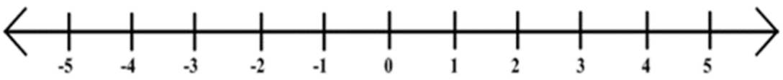

- -5°
- -1°
- 1°
- 5°

N7
Which set of numbers is in ascending order?

- -5, -17, -55, +3, +14, +28
- +3, -5, +14, -17, +28, -55
- -55, -17, -5, +3, +14, +28
- -55, +28, -17, +14, -5, +3

N7
Which temperature is 7 degrees colder than 1° C?

- -8°
- -6°
- 6°
- 8°

N7
Which set of numbers is in ascending order?

- -47, -13, -6, 0, +9, +22
- 0, -6, +9, -13, +22, -47
- -47, +22, -13, 9, -6, 0
- -6, -13, -47, 0, 9, +22

N8
Bill says that 2.34 x 6 = 1404, but he forgot the decimal. Where should he place the
decimal?

- 0.1404
- 1.404
- 14.04
- 140.4

N8
Four students share the cost of a pizza for lunch. The total bill was $17.00. How much did each student pay for their share of the pizza?

- $6.80
- $4.00
- $5.00
- $4.25

N8
Kevin wanted to purchase 6 songs from iTunes. Each song costs $0.99. How much
did Kevin spend?

- $6.99
- $7.00
- $5.94
- $5.01

N8
Jo’s class raised money to donate 8 frozen turkeys to the Food Bank. The average
mass of one turkey was 7.2kg and the average price was $20.50. How much money
did Jo’s class raise?

- $57.60
- $164.00
- $147.60
- $160.00

N8
Charlene says that 15.205 x 4 = 6082, but she forgot the decimal. Where should she
place the decimal?

- 0.6082
- 6.082
- 60.82
- 608.2

N9
Solve: 6 x 7 + (12 + 9) ÷ 3
- 21
B) 43
C) 49
D) 57

N9
Where would you place the brackets in the following expression so that the answer is 10
7 + 3 x 6 ÷ 2 + 4
- (7 + 3) x 6 ÷ 2 + 4
- 7 + 3 x 6 ÷ (2 + 4)
- 7 + 3 x (6 ÷ 2) + 4
- 7 + (3 x 6) ÷ 2 + 4

N9
Where would you place the brackets so that the expression equals 36?
- x 5 + 3 x 5 – 4
A) 2 x (5 + 3) x 5 – 4
B) 2 x 5 + 3 x (5 – 4)
C) 2 x (5 + 3 x 5) – 4
D) 2 x 5 + (3 x 5 – 4)

N9
Before you claim your new car in the Roll Up the Rim contest, you have to answer
the following skill-testing question correctly.
50 ÷ 5 + 8 x (9 + 2) – 6
- 50
- 92
- 158
- 192

N9
Where would you place the brackets in the following expression so that the answer is 23?

3 + 5 x 8 ÷ 4 - 2
- (3 + 5) x 8 ÷ (4 - 2)
- 3 + 5 x 8 ÷ (4 - 2)
- 3 + ( 5 x 8) ÷ 4 - 2
- 3 + 5 x (8 ÷ 4) - 2

